Supplementary data
Alternating Stereospecific Copolymerization of Cyclopentene and Ethylene with Constrained Geometry Catalysts
Adrien R. Lavoie, Michael H. Ho and Robert M. Waymouth*

Table of Contents:

Section A:
Experimental Polymerization Protocol

Section B:
Table 1: ¹³C NMR chemical shifts for cP-E copolymers in 1:3 (d₆-benzene: 1,2,4-trichlorobenzene).
Figure 1: DSC of cP-E copolymer (50% cP) generated with IndSi(Me₂)(^{t}BuN)TiCl₂ at 25 ºC.
Figure 2: DSC of cP-E copolymer (49% cP) generated with IndSi(Me₂)(^{t}BuN)TiCl₂ at 60 ºC.

A. Experimental Polymerization Protocol:
In a nitrogen dry box, a 150 mL Fisher-Porter glass reactor was charged with a teflon stir bar, MMAO-4 (~240 mg, 4 mmol), toluene (3 mL) and 15 mL of dried cP. The glass reactor was affixed with an airtight reactor-head followed by removal from the dry-box. The apparatus was pressurized with the desired feed-gas ratio (up to 20 psig) followed by equilibration at the desired reaction temperature for 30 minutes. During this time, an injection tube was charged with a toluene (2 mL) solution of the desired precatalyst (3-4 mg, 8-10 μmol, 400-500:1 MMAO/metallocene). Following equilibration, the precatalyst/toluene solution was injected with a back-pressure of the feed-gas mixture to initiate the reaction. After the desired reaction time, the reactor was vented to atmospheric pressure and methanol (5 mL) was injected to halt the reaction. The resultant slurry was precipitated with acidified methanol (2 × 300 mL) and the polymer was stirred for several hours followed by filtration to remove residual monomer and Al. The polymer was dried in a vacuum oven at 50 ˚C over-night. Typically, the procedure yields 0.1-3.0 g of polymer. ¹³C NMR spectra of poly(cP-co-E) samples (100 mg) were recorded at 75.4 MHz on a Varian UI300 spectrometer. The samples were dissolved with gentle heating in a 1:3 mixture of d₆-benzene:1,2,4-trichlorobenzene and spectra were obtained at 100°C in 10 mm NMR tubes with a spectral width of 200 ppm, an acquisition time of 4.0 s, and a relaxation delay of 9.5 s.

B. Table 1: ¹³C NMR chemical shifts for cP-E copolymers in 1:3 (d₆-benzene: 1,2,4-trichlorobenzene).

Shift rangeª | sequence^{b} | atom
43.5 | mr/rm | C₂
43.3 | mm | C₂
43.0 | rr | C₂
42.8 | rm/mr | C₂
30.8 | m | C₃
30.6 | r | C₃
30.0-28.2 |  | C_{α}, C_{β}, C_{γ}, C_{δ} …
29.9 | -- | PE (polyethylene)^{c}
28.8-28.2 | mr/rm, mm, rr, rm/mr | C₁
28.7 | m | C₁
22.7 | -- | C₄
^{a13}C NMR acquired in a solution of 1:3 (d₆-benzene: 1,2,4-trichlorobenzene). Referenced to the residual upfield resonance of 1,2,4-trichlorobenzene at 127.5 ppm. ^{b}m = meso, r = racemic. ^{c}polyethylene = PE.

B. Figure 1: DSC of cP-E copolymer (50% cP) generated with IndSi(Me₂)(^{t}BuN)TiCl₂ at 25 ºC.

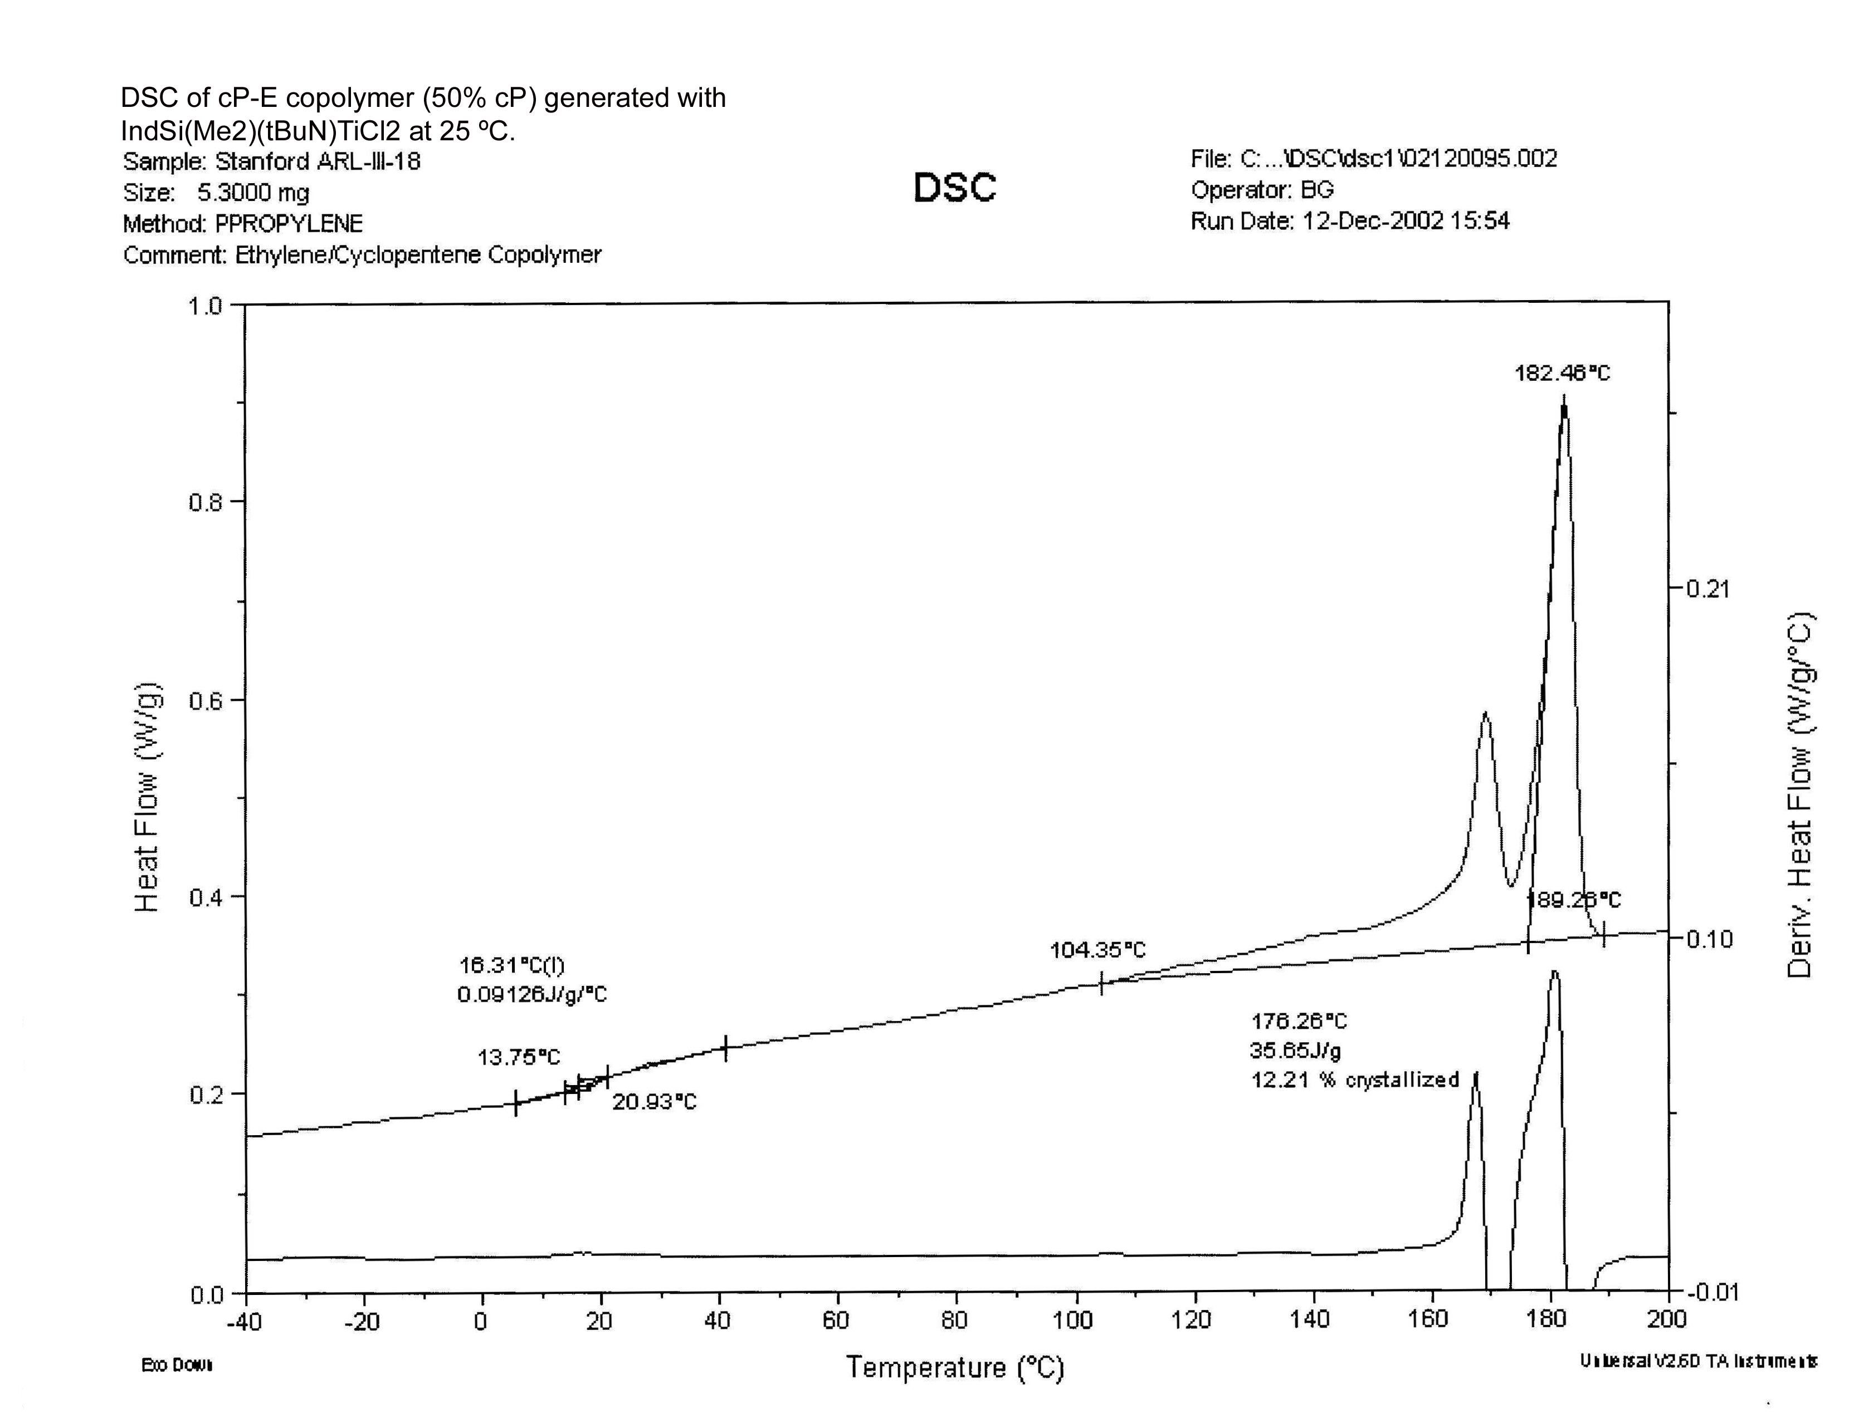

B. Figure 2: DSC of cP-E copolymer (49% cP) generated with IndSi(Me₂)(^{t}BuN)TiCl₂ at 60 ºC.

